**TASK-3**

**Create a hello world fastapi application. Create a Docker file for your fastapi hello world application. Build Docker image using Docker file. Run docker image build in previous step. Push your Docker image to Docker Hub.**

* Main.py file

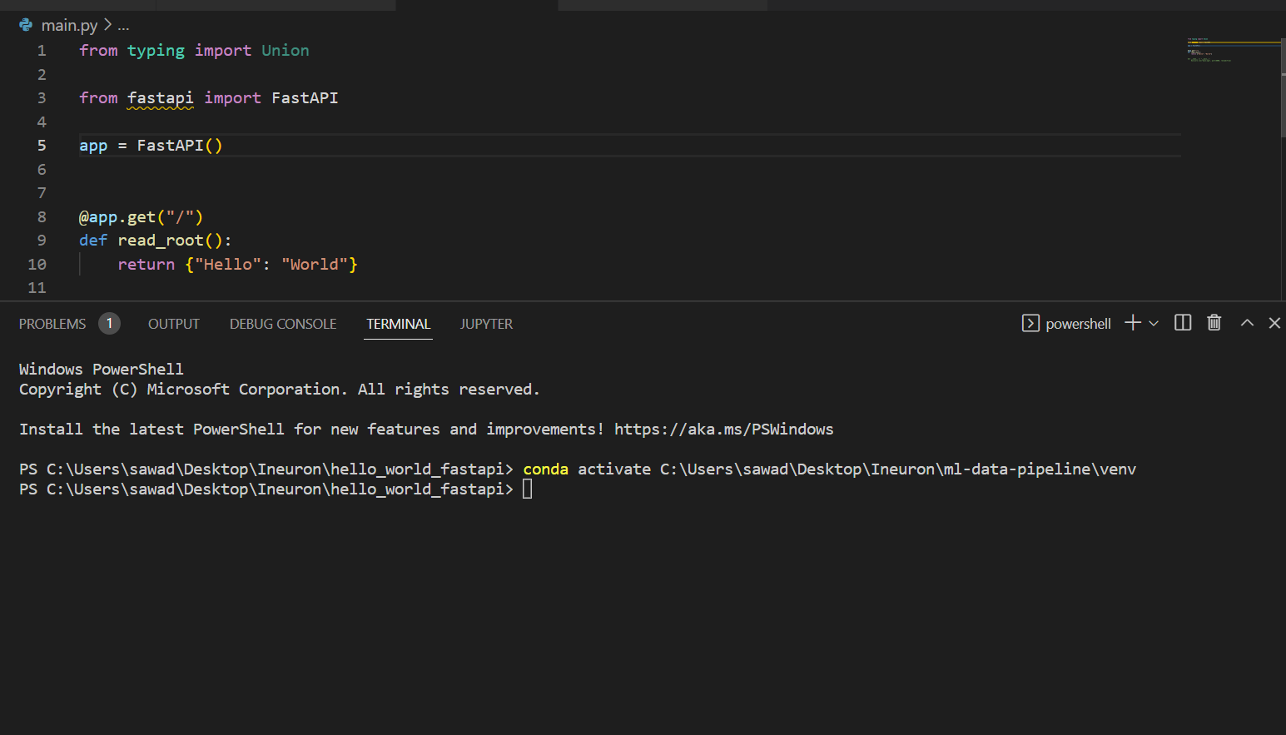

* Requirements.txt file

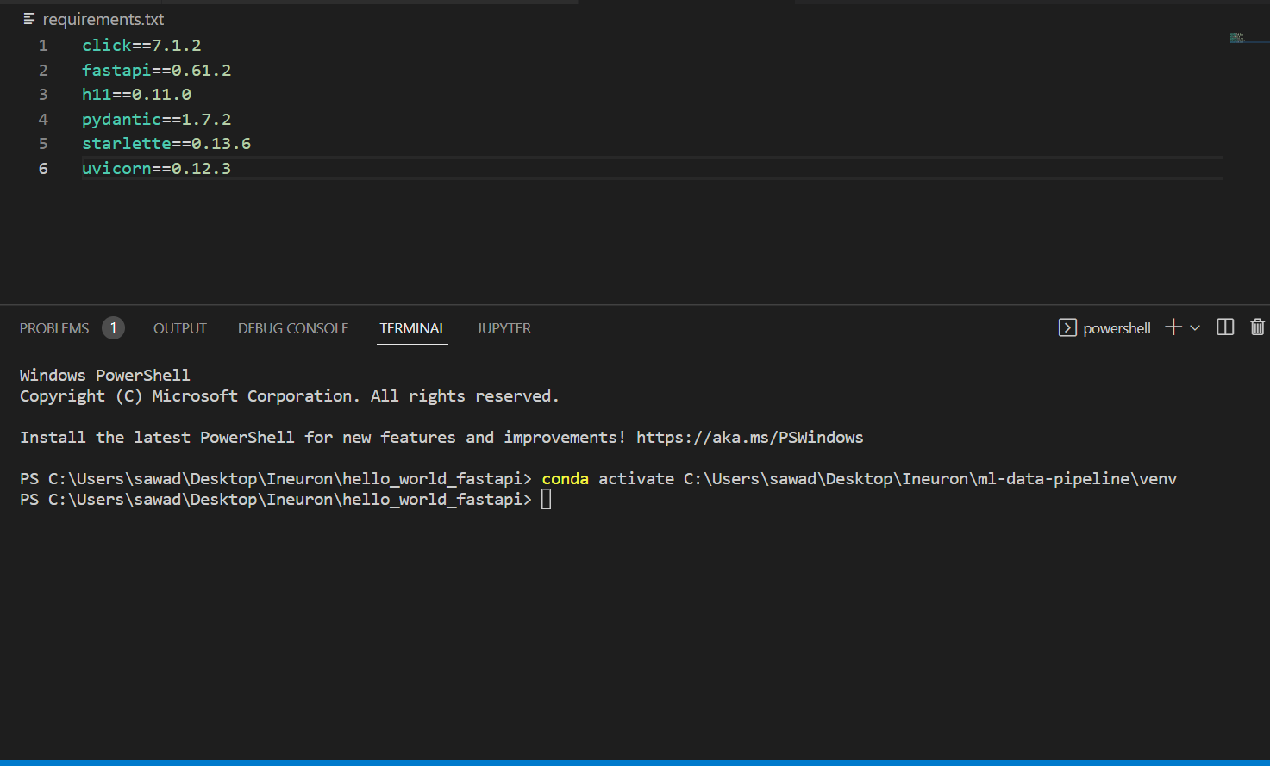

* Install requirements that are required for fastapi .

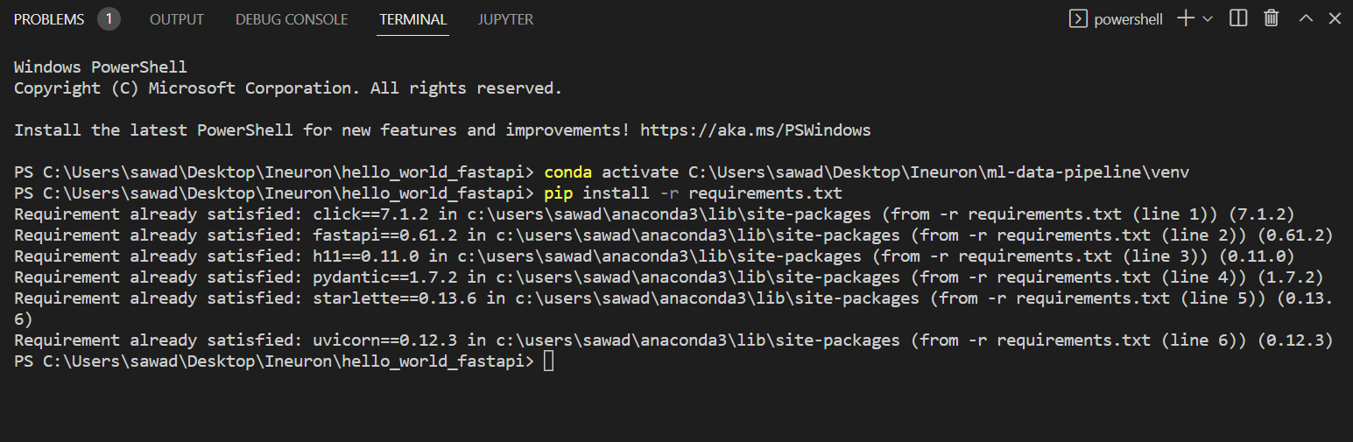

* Run main.py file.

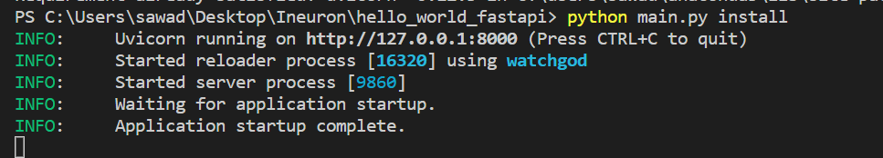

* Run output URL

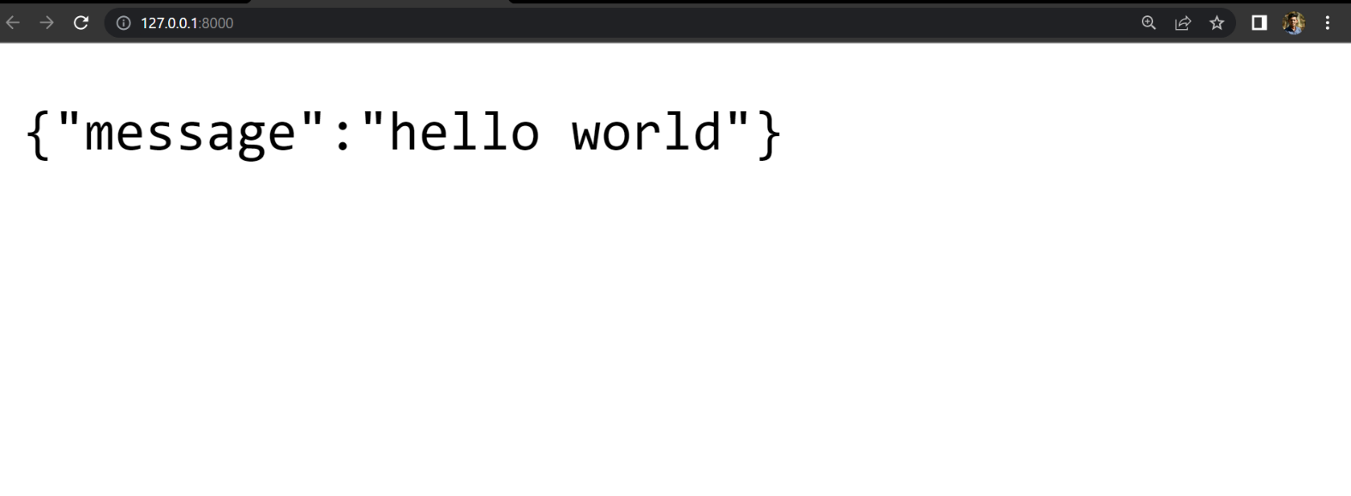

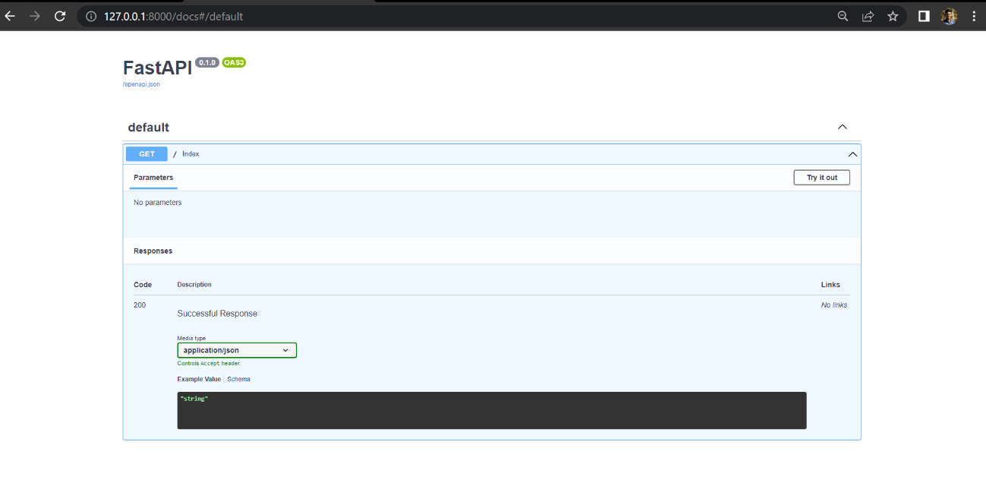

**Build Docker image using Docker file. Run docker image build in previous step. Push your Docker image to Docker Hub.**

* **Build docker image**

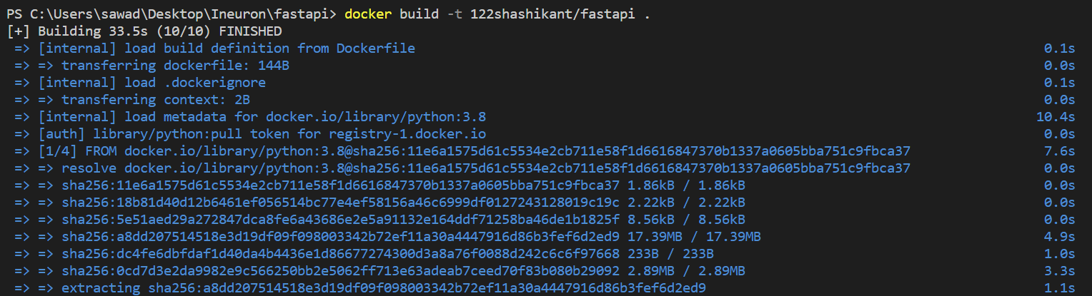

* **Check images that we are build**

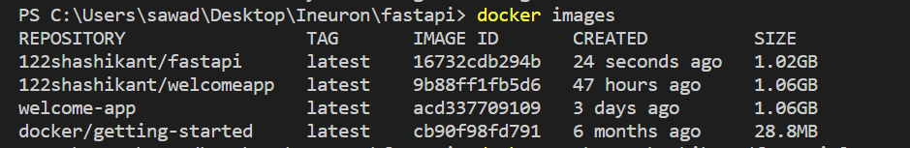

* Push to the docker hub

